**ทฤษฏีที่นำมาใช้**

**Breadth-First Search (BFS)**

เป็นวิธีการค้นหาแบบแนวกว้างก่อน โดยจะค้นหาโหนดที่อยู่ในโครงสร้างต้นไม้ทีละระดับ จากโหนดที่อยู่ด้านซ้ายไปยังโหนดที่อยู่ด้านขวาทีละระดับ (Level) หากยังไม่พบโหนดเป้าหมายให้ลงไปค้นหาโหนดที่อยู่ในระดับถัดไป ทำเช่นนี้ไปเรื่อยๆ จนกว่าจะพบโหนดเป้าหมายที่ต้องการ การค้นหาแบบแนวกว้างก่อนจะใช้โครงสร้างข้อมูลแบบคิว (Queue) เพราะทำงานแบบ FIFO

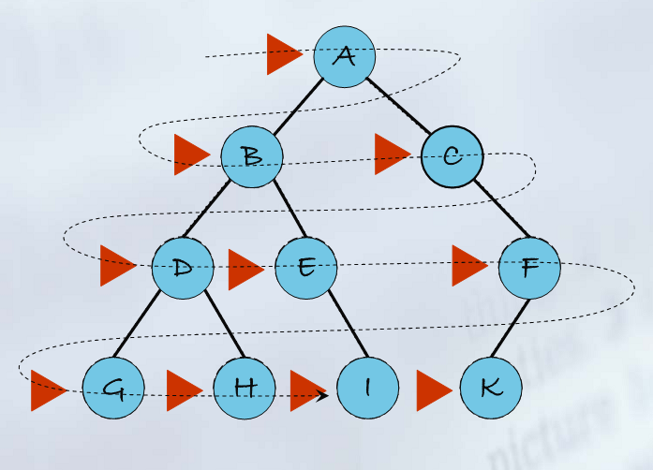  
**รูป การค้นหาแบบ Breadth-First Search**

**ข้อดี**- ถ้ามีคำตอบ ประกันได้ว่าจะพบคำตอบแน่นอน  
- คำตอบที่พบจะเป็นเส้นทางที่สั้นที่สุดไม่ติดในเส้นทางที่ลึกมาก ๆ โดยไม่พบคำตอบ

**ข้อเสีย**- ใช้หน่วยความจำมาก เพราะจำนวนโหนดในแต่ละระดับจะเพิ่มแบบ Exponential  
- เสียเวลามากในกรณีที่คำตอบอยู่ในระดับลึก ถ้าต้นไม้ไม่มีสถานะซ้ำ ๆ กันมาก จะทำให้ต้องสำรวจมากตามไปด้วย

**ตัวอย่าง**

* เช่น กำหนดให้โหนด E เป็นโหนดเป้าหมายของการค้นหาแบบ BFS

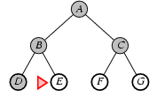  
**รูป การค้นหาโหนดเป้าหมาย**

**โครงสร้างคิวการค้นหา**

|  |  |
| --- | --- |
| **โหนดที่สำรวจ** | **คิว** |
| A | B C |
| B | C D E |
| C | D E F G |
| D | E F G |
| E | F G |

**ตาราง โครงสร้างคิวการค้นหา**

**โจทย์โปรแกรม**

ให้เขียนโปรแกรมแสดงขั้นตอนการค้นหาโหนดใดๆ ด้วยวิธีการค้นหาแบบ Breadth-First Search

**แผนผังการทำงาน**

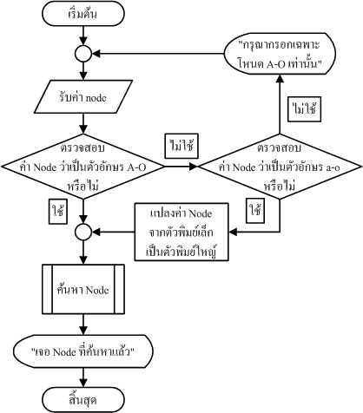

**โปรแกรมย่อยการค้นหาโหนดต่าง ๆ**

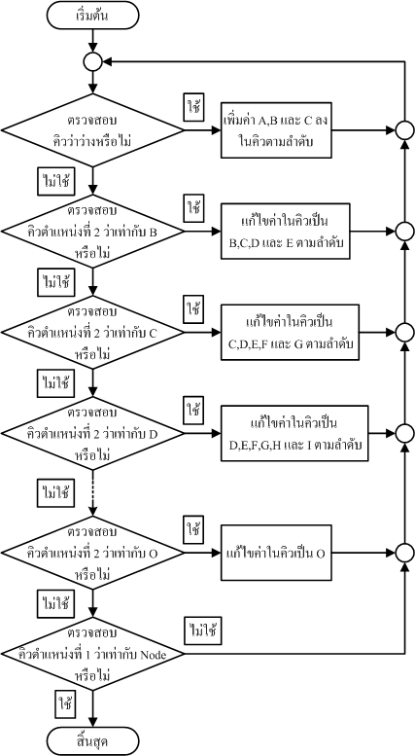

**ส่วนของโปรแกรม**

**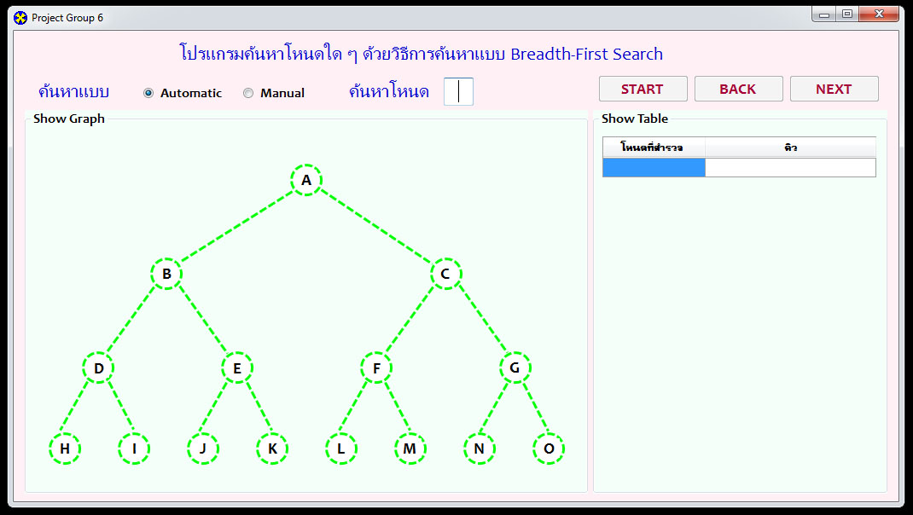  
โปรแกรมจะมีอยู่สองโหมดการทำงานคือ**- Automatic คือการค้นหาอัตโนมัติจนกว่าจะพบโหนดที่ต้องการและหยุดการทำงาน  
- Manual คือการค้นหาโดยการคลิกเป็นระดับไปเรื่อย ๆ จนกว่าจะพบโหนดที่ต้องการด้วยตนเอง

**การค้นหา**ให้กรอกโหนดที่ต้องการลงในช่อง    
เลือกโหมดที่ต้องการ ถ้าเลือก Automatic จะต้องกดปุ่ม Start  
 ถ้าเลือก Manual จะต้องกดปุ่ม Next หรือ Back

**ผลการรันโปรแกรม**

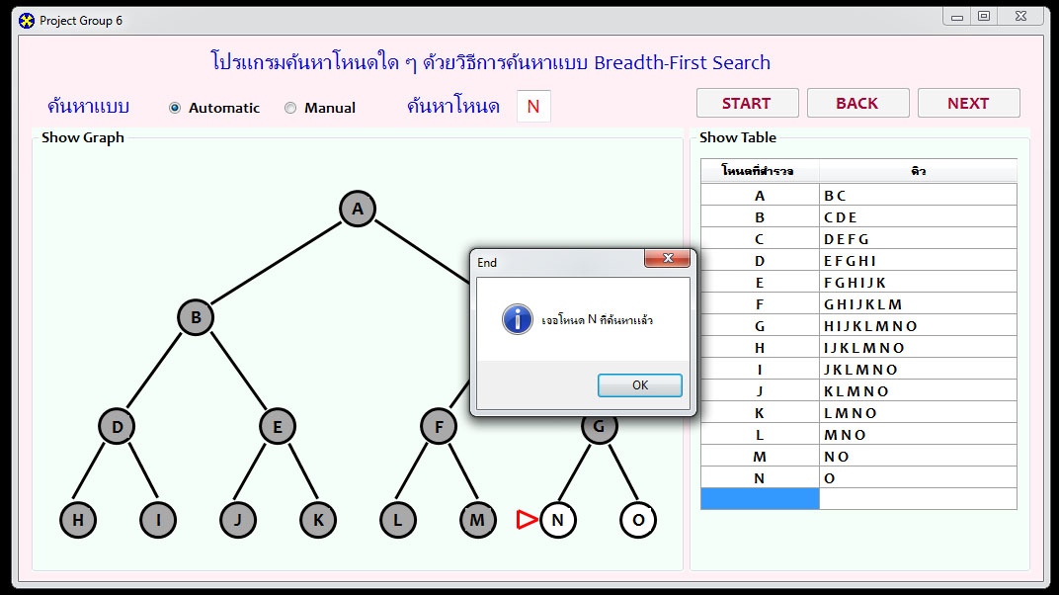

เมื่อค้นหาโหนดที่ต้องการพบ และจะมีตารางคิวแสดงทางด้านขวา  
การแจ้งเตือนจะเกิดขึ้นเมื่อค้นพบโหนดที่ต้องการ

**โค้ดโปรแกรม**

using System;

using System.Collections.Generic;

using System.ComponentModel;

using System.Data;

using System.Drawing;

using System.Linq;

using System.Text;

using System.Windows.Forms;

namespace Project_Breadth_First_Search

{

public partial class Form1 : Form

{

int l = 0;

int b = 0;

public Form1()

{

InitializeComponent();

pa1.BorderColor = Color.MintCream; pa2.BorderColor = Color.MintCream; pa3.BorderColor = Color.MintCream;

pb1.BorderColor = Color.MintCream; pb2.BorderColor = Color.MintCream; pb3.BorderColor = Color.MintCream;

pc1.BorderColor = Color.MintCream; pc2.BorderColor = Color.MintCream; pc3.BorderColor = Color.MintCream;

pd1.BorderColor = Color.MintCream; pd2.BorderColor = Color.MintCream; pd3.BorderColor = Color.MintCream;

pe1.BorderColor = Color.MintCream; pe2.BorderColor = Color.MintCream; pe3.BorderColor = Color.MintCream;

pf1.BorderColor = Color.MintCream; pf2.BorderColor = Color.MintCream; pf3.BorderColor = Color.MintCream;

pg1.BorderColor = Color.MintCream; pg2.BorderColor = Color.MintCream; pg3.BorderColor = Color.MintCream;

ph1.BorderColor = Color.MintCream; ph2.BorderColor = Color.MintCream; ph3.BorderColor = Color.MintCream;

pi1.BorderColor = Color.MintCream; pi2.BorderColor = Color.MintCream; pi3.BorderColor = Color.MintCream;

pj1.BorderColor = Color.MintCream; pj2.BorderColor = Color.MintCream; pj3.BorderColor = Color.MintCream;

pk1.BorderColor = Color.MintCream; pk2.BorderColor = Color.MintCream; pk3.BorderColor = Color.MintCream;

pl1.BorderColor = Color.MintCream; pl2.BorderColor = Color.MintCream; pl3.BorderColor = Color.MintCream;

pm1.BorderColor = Color.MintCream; pm2.BorderColor = Color.MintCream; pm3.BorderColor = Color.MintCream;

pn1.BorderColor = Color.MintCream; pn2.BorderColor = Color.MintCream; pn3.BorderColor = Color.MintCream;

po1.BorderColor = Color.MintCream; po2.BorderColor = Color.MintCream; po3.BorderColor = Color.MintCream;

start.Enabled = true ;back.Enabled = false; next.Enabled = false;

}

private void Form1_Load(object sender, EventArgs e)

{

}

private void start_Click(object sender, EventArgs e)

{

String c = job_node.Text;

switch (c)

{

case "a": job_node.Text = "A"; break;

case "b": job_node.Text = "B"; break;

case "c": job_node.Text = "C"; break;

case "d": job_node.Text = "D"; break;

case "e": job_node.Text = "E"; break;

case "f": job_node.Text = "F"; break;

case "g": job_node.Text = "G"; break;

case "h": job_node.Text = "H"; break;

case "i": job_node.Text = "I"; break;

case "j": job_node.Text = "J"; break;

case "k": job_node.Text = "K"; break;

case "l": job_node.Text = "L"; break;

case "m": job_node.Text = "M"; break;

case "n": job_node.Text = "N"; break;

case "o": job_node.Text = "O"; break;

}

if (automatic.Checked == true && start.Text.Equals("START"))

{

start.Enabled = false;

run.Enabled = true;

}

else if (automatic.Checked == true && start.Text.Equals("FINISH"))

{

job_node.Enabled = true;

start.Text = "START";

Del_Search();

}

else {

if (start.Text.Equals("START"))

{

job_node.Enabled = false;

start.Text = "RESET";

next.Enabled = true;

Next_Search();

}

else if (start.Text.Equals("RESET"))

{

job_node.Enabled = true;

start.Text = "START";

back.Enabled = false;

next.Enabled = false;

Del_Search();

}

else

{

job_node.Enabled = true;

start.Text = "START";

Del_Search();

}

}

}

private void back_Click(object sender, EventArgs e)

{

Back_Search();

}

private void next_Click(object sender, EventArgs e)

{

back.Enabled = true;

Next_Search();

}

private void Del_Search()

{

int chk = tlist.Rows.Count;

for (int i = 1; i < chk;i++) {

//MessageBox.Show(chk+" - "+i+"");

tlist.Rows.RemoveAt(0);

}

node_a.BorderStyle = System.Drawing.Drawing2D.DashStyle.Dash;node_a.BorderColor = Color.Lime;node_a.FillColor = Color.White;

node_b.BorderStyle = System.Drawing.Drawing2D.DashStyle.Dash;node_b.BorderColor = Color.Lime;node_b.FillColor = Color.White;

node_c.BorderStyle = System.Drawing.Drawing2D.DashStyle.Dash;node_c.BorderColor = Color.Lime;node_c.FillColor = Color.White;

node_d.BorderStyle = System.Drawing.Drawing2D.DashStyle.Dash;node_d.BorderColor = Color.Lime;node_d.FillColor = Color.White;

node_e.BorderStyle = System.Drawing.Drawing2D.DashStyle.Dash;node_e.BorderColor = Color.Lime;node_e.FillColor = Color.White;

node_f.BorderStyle = System.Drawing.Drawing2D.DashStyle.Dash;node_f.BorderColor = Color.Lime;node_f.FillColor = Color.White;

node_g.BorderStyle = System.Drawing.Drawing2D.DashStyle.Dash;node_g.BorderColor = Color.Lime;node_g.FillColor = Color.White;

node_h.BorderStyle = System.Drawing.Drawing2D.DashStyle.Dash;node_h.BorderColor = Color.Lime;node_h.FillColor = Color.White;

node_i.BorderStyle = System.Drawing.Drawing2D.DashStyle.Dash;node_i.BorderColor = Color.Lime;node_i.FillColor = Color.White;

node_j.BorderStyle = System.Drawing.Drawing2D.DashStyle.Dash;node_j.BorderColor = Color.Lime;node_j.FillColor = Color.White;

node_k.BorderStyle = System.Drawing.Drawing2D.DashStyle.Dash;node_k.BorderColor = Color.Lime;node_k.FillColor = Color.White;

node_l.BorderStyle = System.Drawing.Drawing2D.DashStyle.Dash;node_l.BorderColor = Color.Lime;node_l.FillColor = Color.White;

node_m.BorderStyle = System.Drawing.Drawing2D.DashStyle.Dash;node_m.BorderColor = Color.Lime;node_m.FillColor = Color.White;

node_n.BorderStyle = System.Drawing.Drawing2D.DashStyle.Dash;node_n.BorderColor = Color.Lime;node_n.FillColor = Color.White;

node_o.BorderStyle = System.Drawing.Drawing2D.DashStyle.Dash;node_o.BorderColor = Color.Lime;node_o.FillColor = Color.White;

pa1.BorderColor = Color.MintCream; pa2.BorderColor = Color.MintCream; pa3.BorderColor = Color.MintCream;

pb1.BorderColor = Color.MintCream; pb2.BorderColor = Color.MintCream; pb3.BorderColor = Color.MintCream;

pc1.BorderColor = Color.MintCream; pc2.BorderColor = Color.MintCream; pc3.BorderColor = Color.MintCream;

pd1.BorderColor = Color.MintCream; pd2.BorderColor = Color.MintCream; pd3.BorderColor = Color.MintCream;

pe1.BorderColor = Color.MintCream; pe2.BorderColor = Color.MintCream; pe3.BorderColor = Color.MintCream;

pf1.BorderColor = Color.MintCream; pf2.BorderColor = Color.MintCream; pf3.BorderColor = Color.MintCream;

pg1.BorderColor = Color.MintCream; pg2.BorderColor = Color.MintCream; pg3.BorderColor = Color.MintCream;

ph1.BorderColor = Color.MintCream; ph2.BorderColor = Color.MintCream; ph3.BorderColor = Color.MintCream;

pi1.BorderColor = Color.MintCream; pi2.BorderColor = Color.MintCream; pi3.BorderColor = Color.MintCream;

pj1.BorderColor = Color.MintCream; pj2.BorderColor = Color.MintCream; pj3.BorderColor = Color.MintCream;

pk1.BorderColor = Color.MintCream; pk2.BorderColor = Color.MintCream; pk3.BorderColor = Color.MintCream;

pl1.BorderColor = Color.MintCream; pl2.BorderColor = Color.MintCream; pl3.BorderColor = Color.MintCream;

pm1.BorderColor = Color.MintCream; pm2.BorderColor = Color.MintCream; pm3.BorderColor = Color.MintCream;

pn1.BorderColor = Color.MintCream; pn2.BorderColor = Color.MintCream; pn3.BorderColor = Color.MintCream;

po1.BorderColor = Color.MintCream; po2.BorderColor = Color.MintCream; po3.BorderColor = Color.MintCream;

line_b.BorderStyle = System.Drawing.Drawing2D.DashStyle.Dash;line_b.BorderColor = Color.Lime;

line_c.BorderStyle = System.Drawing.Drawing2D.DashStyle.Dash;line_c.BorderColor = Color.Lime;

line_d.BorderStyle = System.Drawing.Drawing2D.DashStyle.Dash;line_d.BorderColor = Color.Lime;

line_e.BorderStyle = System.Drawing.Drawing2D.DashStyle.Dash;line_e.BorderColor = Color.Lime;

line_f.BorderStyle = System.Drawing.Drawing2D.DashStyle.Dash;line_f.BorderColor = Color.Lime;

line_g.BorderStyle = System.Drawing.Drawing2D.DashStyle.Dash;line_g.BorderColor = Color.Lime;

line_h.BorderStyle = System.Drawing.Drawing2D.DashStyle.Dash;line_h.BorderColor = Color.Lime;

line_i.BorderStyle = System.Drawing.Drawing2D.DashStyle.Dash;line_i.BorderColor = Color.Lime;

line_j.BorderStyle = System.Drawing.Drawing2D.DashStyle.Dash;line_j.BorderColor = Color.Lime;

line_k.BorderStyle = System.Drawing.Drawing2D.DashStyle.Dash;line_k.BorderColor = Color.Lime;

line_l.BorderStyle = System.Drawing.Drawing2D.DashStyle.Dash;line_l.BorderColor = Color.Lime;

line_m.BorderStyle = System.Drawing.Drawing2D.DashStyle.Dash;line_m.BorderColor = Color.Lime;

line_n.BorderStyle = System.Drawing.Drawing2D.DashStyle.Dash;line_n.BorderColor = Color.Lime;

line_o.BorderStyle = System.Drawing.Drawing2D.DashStyle.Dash;line_o.BorderColor = Color.Lime;

lb_a.BackColor = Color.White;lb_b.BackColor = Color.White;lb_c.BackColor = Color.White;

lb_d.BackColor = Color.White;lb_e.BackColor = Color.White;lb_f.BackColor = Color.White;

lb_g.BackColor = Color.White;lb_h.BackColor = Color.White;lb_i.BackColor = Color.White;

lb_j.BackColor = Color.White;lb_k.BackColor = Color.White;lb_l.BackColor = Color.White;

lb_m.BackColor = Color.White;lb_n.BackColor = Color.White;lb_o.BackColor = Color.White;

l = 0;

}

private void Back_Search()

{

String s = tlist[0, l - 1].Value + "";

//MessageBox.Show(s);

if (s == "B")

{

tlist.Rows.RemoveAt(l-1);

pb1.BorderColor = Color.MintCream; pb2.BorderColor = Color.MintCream; pb3.BorderColor = Color.MintCream;

pa1.BorderColor = Color.Red; pa2.BorderColor = Color.Red; pa3.BorderColor = Color.Red;

node_a.FillColor = Color.White;

lb_a.BackColor = Color.White;

node_b.BorderStyle = System.Drawing.Drawing2D.DashStyle.Dash;

node_b.BorderColor = Color.Lime;

line_b.BorderStyle = System.Drawing.Drawing2D.DashStyle.Dash;

line_b.BorderColor = Color.Lime;

node_c.BorderStyle = System.Drawing.Drawing2D.DashStyle.Dash;

node_c.BorderColor = Color.Lime;

line_c.BorderStyle = System.Drawing.Drawing2D.DashStyle.Dash;

line_c.BorderColor = Color.Lime;

back.Enabled = false;

}

else if (s == "C")

{

tlist.Rows.RemoveAt(l - 1);

pc1.BorderColor = Color.MintCream; pc2.BorderColor = Color.MintCream; pc3.BorderColor = Color.MintCream;

pb1.BorderColor = Color.Red; pb2.BorderColor = Color.Red; pb3.BorderColor = Color.Red;

node_b.FillColor = Color.White;

lb_b.BackColor = Color.White;

node_d.BorderStyle = System.Drawing.Drawing2D.DashStyle.Dash;

node_d.BorderColor = Color.Lime;

line_d.BorderStyle = System.Drawing.Drawing2D.DashStyle.Dash;

line_d.BorderColor = Color.Lime;

node_e.BorderStyle = System.Drawing.Drawing2D.DashStyle.Dash;

node_e.BorderColor = Color.Lime;

line_e.BorderStyle = System.Drawing.Drawing2D.DashStyle.Dash;

line_e.BorderColor = Color.Lime;

}

else if (s == "D")

{

tlist.Rows.RemoveAt(l - 1);

pd1.BorderColor = Color.MintCream; pd2.BorderColor = Color.MintCream; pd3.BorderColor = Color.MintCream;

pc1.BorderColor = Color.Red; pc2.BorderColor = Color.Red; pc3.BorderColor = Color.Red;

node_c.FillColor = Color.White;

lb_c.BackColor = Color.White;

node_f.BorderStyle = System.Drawing.Drawing2D.DashStyle.Dash;

node_f.BorderColor = Color.Lime;

line_f.BorderStyle = System.Drawing.Drawing2D.DashStyle.Dash;

line_f.BorderColor = Color.Lime;

node_g.BorderStyle = System.Drawing.Drawing2D.DashStyle.Dash;

node_g.BorderColor = Color.Lime;

line_g.BorderStyle = System.Drawing.Drawing2D.DashStyle.Dash;

line_g.BorderColor = Color.Lime;

}

else if (s == "E")

{

tlist.Rows.RemoveAt(l - 1);

pe1.BorderColor = Color.MintCream; pe2.BorderColor = Color.MintCream; pe3.BorderColor = Color.MintCream;

pd1.BorderColor = Color.Red; pd2.BorderColor = Color.Red; pd3.BorderColor = Color.Red;

node_d.FillColor = Color.White;

lb_d.BackColor = Color.White;

node_h.BorderStyle = System.Drawing.Drawing2D.DashStyle.Dash;

node_h.BorderColor = Color.Lime;

line_h.BorderStyle = System.Drawing.Drawing2D.DashStyle.Dash;

line_h.BorderColor = Color.Lime;

node_i.BorderStyle = System.Drawing.Drawing2D.DashStyle.Dash;

node_i.BorderColor = Color.Lime;

line_i.BorderStyle = System.Drawing.Drawing2D.DashStyle.Dash;

line_i.BorderColor = Color.Lime;

}

else if (s == "F")

{

tlist.Rows.RemoveAt(l - 1);

pf1.BorderColor = Color.MintCream; pf2.BorderColor = Color.MintCream; pf3.BorderColor = Color.MintCream;

pe1.BorderColor = Color.Red; pe2.BorderColor = Color.Red; pe3.BorderColor = Color.Red;

node_e.FillColor = Color.White;

lb_e.BackColor = Color.White;

node_j.BorderStyle = System.Drawing.Drawing2D.DashStyle.Dash;

node_j.BorderColor = Color.Lime;

line_j.BorderStyle = System.Drawing.Drawing2D.DashStyle.Dash;

line_j.BorderColor = Color.Lime;

node_k.BorderStyle = System.Drawing.Drawing2D.DashStyle.Dash;

node_k.BorderColor = Color.Lime;

line_k.BorderStyle = System.Drawing.Drawing2D.DashStyle.Dash;

line_k.BorderColor = Color.Lime;

}

else if (s == "G")

{

tlist.Rows.RemoveAt(l - 1);

pg1.BorderColor = Color.MintCream; pg2.BorderColor = Color.MintCream; pg3.BorderColor = Color.MintCream;

pf1.BorderColor = Color.Red; pf2.BorderColor = Color.Red; pf3.BorderColor = Color.Red;

node_f.FillColor = Color.White;

lb_f.BackColor = Color.White;

node_l.BorderStyle = System.Drawing.Drawing2D.DashStyle.Dash;

node_l.BorderColor = Color.Lime;

line_l.BorderStyle = System.Drawing.Drawing2D.DashStyle.Dash;

line_l.BorderColor = Color.Lime;

node_m.BorderStyle = System.Drawing.Drawing2D.DashStyle.Dash;

node_m.BorderColor = Color.Lime;

line_m.BorderStyle = System.Drawing.Drawing2D.DashStyle.Dash;

line_m.BorderColor = Color.Lime;

}

else if (s == "H")

{

tlist.Rows.RemoveAt(l - 1);

ph1.BorderColor = Color.MintCream; ph2.BorderColor = Color.MintCream; ph3.BorderColor = Color.MintCream;

pg1.BorderColor = Color.Red; pg2.BorderColor = Color.Red; pg3.BorderColor = Color.Red;

node_g.FillColor = Color.White;

lb_g.BackColor = Color.White;

node_n.BorderStyle = System.Drawing.Drawing2D.DashStyle.Dash;

node_n.BorderColor = Color.Lime;

line_n.BorderStyle = System.Drawing.Drawing2D.DashStyle.Dash;

line_n.BorderColor = Color.Lime;

node_o.BorderStyle = System.Drawing.Drawing2D.DashStyle.Dash;

node_o.BorderColor = Color.Lime;

line_o.BorderStyle = System.Drawing.Drawing2D.DashStyle.Dash;

line_o.BorderColor = Color.Lime;

}

else if (s == "I")

{

tlist.Rows.RemoveAt(l - 1);

pi1.BorderColor = Color.MintCream; pi2.BorderColor = Color.MintCream; pi3.BorderColor = Color.MintCream;

ph1.BorderColor = Color.Red; ph2.BorderColor = Color.Red; ph3.BorderColor = Color.Red;

node_h.FillColor = Color.White;

lb_h.BackColor = Color.White;

}

else if (s == "J")

{

tlist.Rows.RemoveAt(l - 1);

pj1.BorderColor = Color.MintCream; pj2.BorderColor = Color.MintCream; pj3.BorderColor = Color.MintCream;

pi1.BorderColor = Color.Red; pi2.BorderColor = Color.Red; pi3.BorderColor = Color.Red;

node_i.FillColor = Color.White;

lb_i.BackColor = Color.White;

}

else if (s == "K")

{

tlist.Rows.RemoveAt(l - 1);

pk1.BorderColor = Color.MintCream; pk2.BorderColor = Color.MintCream; pk3.BorderColor = Color.MintCream;

pj1.BorderColor = Color.Red; pj2.BorderColor = Color.Red; pj3.BorderColor = Color.Red;

node_j.FillColor = Color.White;

lb_j.BackColor = Color.White;

}

else if (s == "L")

{

tlist.Rows.RemoveAt(l - 1);

pl1.BorderColor = Color.MintCream; pl2.BorderColor = Color.MintCream; pl3.BorderColor = Color.MintCream;

pk1.BorderColor = Color.Red; pk2.BorderColor = Color.Red; pk3.BorderColor = Color.Red;

node_k.FillColor = Color.White;

lb_k.BackColor = Color.White;

}

else if (s == "M")

{

tlist.Rows.RemoveAt(l - 1);

pm1.BorderColor = Color.MintCream; pm2.BorderColor = Color.MintCream; pm3.BorderColor = Color.MintCream;

pl1.BorderColor = Color.Red; pl2.BorderColor = Color.Red; pl3.BorderColor = Color.Red;

node_l.FillColor = Color.White;

lb_l.BackColor = Color.White;

}

else if (s == "N")

{

tlist.Rows.RemoveAt(l - 1);

pn1.BorderColor = Color.MintCream; pn2.BorderColor = Color.MintCream; pn3.BorderColor = Color.MintCream;

pm1.BorderColor = Color.Red; pm2.BorderColor = Color.Red; pm3.BorderColor = Color.Red;

node_m.FillColor = Color.White;

lb_m.BackColor = Color.White;

}

else if (s == "O")

{

tlist.Rows.RemoveAt(l - 1);

po1.BorderColor = Color.MintCream; po2.BorderColor = Color.MintCream; po3.BorderColor = Color.MintCream;

pn1.BorderColor = Color.Red; pn2.BorderColor = Color.Red; pn3.BorderColor = Color.Red;

node_n.FillColor = Color.White;

lb_n.BackColor = Color.White;

}

l--;

}

private void Next_Search(){

if (tlist[0, 0].Value+""=="")

{

pa1.BorderColor = Color.Red; pa2.BorderColor = Color.Red; pa3.BorderColor = Color.Red;

node_a.BorderStyle = System.Drawing.Drawing2D.DashStyle.Solid;

node_a.BorderColor = Color.Black;

tlist.Rows.Add("A","B C");

}

else {

String s = tlist[1, l - 1].Value + "";

if (s.Substring(0, 1)=="B") {

tlist.Rows.Add("B", "C D E");

pa1.BorderColor = Color.MintCream; pa2.BorderColor = Color.MintCream; pa3.BorderColor = Color.MintCream;

pb1.BorderColor = Color.Red; pb2.BorderColor = Color.Red; pb3.BorderColor = Color.Red;

node_a.FillColor = Color.DarkGray;

lb_a.BackColor = Color.DarkGray;

node_b.BorderStyle = System.Drawing.Drawing2D.DashStyle.Solid;

node_b.BorderColor = Color.Black;

line_b.BorderStyle = System.Drawing.Drawing2D.DashStyle.Solid;

line_b.BorderColor = Color.Black;

node_c.BorderStyle = System.Drawing.Drawing2D.DashStyle.Solid;

node_c.BorderColor = Color.Black;

line_c.BorderStyle = System.Drawing.Drawing2D.DashStyle.Solid;

line_c.BorderColor = Color.Black;

}

else if (s.Substring(0, 1) == "C")

{

tlist.Rows.Add("C", "D E F G");

pb1.BorderColor = Color.MintCream; pb2.BorderColor = Color.MintCream; pb3.BorderColor = Color.MintCream;

pc1.BorderColor = Color.Red; pc2.BorderColor = Color.Red; pc3.BorderColor = Color.Red;

node_b.FillColor = Color.DarkGray;

lb_b.BackColor = Color.DarkGray;

node_d.BorderStyle = System.Drawing.Drawing2D.DashStyle.Solid;

node_d.BorderColor = Color.Black;

line_d.BorderStyle = System.Drawing.Drawing2D.DashStyle.Solid;

line_d.BorderColor = Color.Black;

node_e.BorderStyle = System.Drawing.Drawing2D.DashStyle.Solid;

node_e.BorderColor = Color.Black;

line_e.BorderStyle = System.Drawing.Drawing2D.DashStyle.Solid;

line_e.BorderColor = Color.Black;

}

else if (s.Substring(0, 1) == "D")

{

tlist.Rows.Add("D", "E F G H I");

pc1.BorderColor = Color.MintCream; pc2.BorderColor = Color.MintCream; pc3.BorderColor = Color.MintCream;

pd1.BorderColor = Color.Red; pd2.BorderColor = Color.Red; pd3.BorderColor = Color.Red;

node_c.FillColor = Color.DarkGray;

lb_c.BackColor = Color.DarkGray;

node_f.BorderStyle = System.Drawing.Drawing2D.DashStyle.Solid;

node_f.BorderColor = Color.Black;

line_f.BorderStyle = System.Drawing.Drawing2D.DashStyle.Solid;

line_f.BorderColor = Color.Black;

node_g.BorderStyle = System.Drawing.Drawing2D.DashStyle.Solid;

node_g.BorderColor = Color.Black;

line_g.BorderStyle = System.Drawing.Drawing2D.DashStyle.Solid;

line_g.BorderColor = Color.Black;

}

else if (s.Substring(0, 1) == "E")

{

tlist.Rows.Add("E", "F G H I J K");

pd1.BorderColor = Color.MintCream; pd2.BorderColor = Color.MintCream; pd3.BorderColor = Color.MintCream;

pe1.BorderColor = Color.Red; pe2.BorderColor = Color.Red; pe3.BorderColor = Color.Red;

node_d.FillColor = Color.DarkGray;

lb_d.BackColor = Color.DarkGray;

node_h.BorderStyle = System.Drawing.Drawing2D.DashStyle.Solid;

node_h.BorderColor = Color.Black;

line_h.BorderStyle = System.Drawing.Drawing2D.DashStyle.Solid;

line_h.BorderColor = Color.Black;

node_i.BorderStyle = System.Drawing.Drawing2D.DashStyle.Solid;

node_i.BorderColor = Color.Black;

line_i.BorderStyle = System.Drawing.Drawing2D.DashStyle.Solid;

line_i.BorderColor = Color.Black;

}

else if (s.Substring(0, 1) == "F")

{

tlist.Rows.Add("F", "G H I J K L M");

pe1.BorderColor = Color.MintCream; pe2.BorderColor = Color.MintCream; pe3.BorderColor = Color.MintCream;

pf1.BorderColor = Color.Red; pf2.BorderColor = Color.Red; pf3.BorderColor = Color.Red;

node_e.FillColor = Color.DarkGray;

lb_e.BackColor = Color.DarkGray;

node_j.BorderStyle = System.Drawing.Drawing2D.DashStyle.Solid;

node_j.BorderColor = Color.Black;

line_j.BorderStyle = System.Drawing.Drawing2D.DashStyle.Solid;

line_j.BorderColor = Color.Black;

node_k.BorderStyle = System.Drawing.Drawing2D.DashStyle.Solid;

node_k.BorderColor = Color.Black;

line_k.BorderStyle = System.Drawing.Drawing2D.DashStyle.Solid;

line_k.BorderColor = Color.Black;

}

else if (s.Substring(0, 1) == "G")

{

tlist.Rows.Add("G", "H I J K L M N O");

pf1.BorderColor = Color.MintCream; pf2.BorderColor = Color.MintCream; pf3.BorderColor = Color.MintCream;

pg1.BorderColor = Color.Red; pg2.BorderColor = Color.Red; pg3.BorderColor = Color.Red;

node_f.FillColor = Color.DarkGray;

lb_f.BackColor = Color.DarkGray;

node_l.BorderStyle = System.Drawing.Drawing2D.DashStyle.Solid;

node_l.BorderColor = Color.Black;

line_l.BorderStyle = System.Drawing.Drawing2D.DashStyle.Solid;

line_l.BorderColor = Color.Black;

node_m.BorderStyle = System.Drawing.Drawing2D.DashStyle.Solid;

node_m.BorderColor = Color.Black;

line_m.BorderStyle = System.Drawing.Drawing2D.DashStyle.Solid;

line_m.BorderColor = Color.Black;

}

else if (s.Substring(0, 1) == "H")

{

tlist.Rows.Add("H", "I J K L M N O");

pg1.BorderColor = Color.MintCream; pg2.BorderColor = Color.MintCream; pg3.BorderColor = Color.MintCream;

ph1.BorderColor = Color.Red; ph2.BorderColor = Color.Red; ph3.BorderColor = Color.Red;

node_g.FillColor = Color.DarkGray;

lb_g.BackColor = Color.DarkGray;

node_n.BorderStyle = System.Drawing.Drawing2D.DashStyle.Solid;

node_n.BorderColor = Color.Black;

line_n.BorderStyle = System.Drawing.Drawing2D.DashStyle.Solid;

line_n.BorderColor = Color.Black;

node_o.BorderStyle = System.Drawing.Drawing2D.DashStyle.Solid;

node_o.BorderColor = Color.Black;

line_o.BorderStyle = System.Drawing.Drawing2D.DashStyle.Solid;

line_o.BorderColor = Color.Black;

}

else if (s.Substring(0, 1) == "I")

{

tlist.Rows.Add("I", "J K L M N O");

ph1.BorderColor = Color.MintCream; ph2.BorderColor = Color.MintCream; ph3.BorderColor = Color.MintCream;

pi1.BorderColor = Color.Red; pi2.BorderColor = Color.Red; pi3.BorderColor = Color.Red;

node_h.FillColor = Color.DarkGray;

lb_h.BackColor = Color.DarkGray;

}

else if (s.Substring(0, 1) == "J")

{

tlist.Rows.Add("J", "K L M N O");

pi1.BorderColor = Color.MintCream; pi2.BorderColor = Color.MintCream; pi3.BorderColor = Color.MintCream;

pj1.BorderColor = Color.Red; pj2.BorderColor = Color.Red; pj3.BorderColor = Color.Red;

node_i.FillColor = Color.DarkGray;

lb_i.BackColor = Color.DarkGray;

}

else if (s.Substring(0, 1) == "K")

{

tlist.Rows.Add("K", "L M N O");

pj1.BorderColor = Color.MintCream; pj2.BorderColor = Color.MintCream; pj3.BorderColor = Color.MintCream;

pk1.BorderColor = Color.Red; pk2.BorderColor = Color.Red; pk3.BorderColor = Color.Red;

node_j.FillColor = Color.DarkGray;

lb_j.BackColor = Color.DarkGray;

}

else if (s.Substring(0, 1) == "L")

{

tlist.Rows.Add("L", "M N O");

pk1.BorderColor = Color.MintCream; pk2.BorderColor = Color.MintCream; pk3.BorderColor = Color.MintCream;

pl1.BorderColor = Color.Red; pl2.BorderColor = Color.Red; pl3.BorderColor = Color.Red;

node_k.FillColor = Color.DarkGray;

lb_k.BackColor = Color.DarkGray;

}

else if (s.Substring(0, 1) == "M")

{

tlist.Rows.Add("M", "N O");

pl1.BorderColor = Color.MintCream; pl2.BorderColor = Color.MintCream; pl3.BorderColor = Color.MintCream;

pm1.BorderColor = Color.Red; pm2.BorderColor = Color.Red; pm3.BorderColor = Color.Red;

node_l.FillColor = Color.DarkGray;

lb_l.BackColor = Color.DarkGray;

}

else if (s.Substring(0, 1) == "N")

{

tlist.Rows.Add("N", "O");

pm1.BorderColor = Color.MintCream; pm2.BorderColor = Color.MintCream; pm3.BorderColor = Color.MintCream;

pn1.BorderColor = Color.Red; pn2.BorderColor = Color.Red; pn3.BorderColor = Color.Red;

node_m.FillColor = Color.DarkGray;

lb_m.BackColor = Color.DarkGray;

}

else if (s.Substring(0, 1) == "O")

{

tlist.Rows.Add("O", "");

pn1.BorderColor = Color.MintCream; pn2.BorderColor = Color.MintCream; pn3.BorderColor = Color.MintCream;

po1.BorderColor = Color.Red; po2.BorderColor = Color.Red; po3.BorderColor = Color.Red;

node_n.FillColor = Color.DarkGray;

lb_n.BackColor = Color.DarkGray;

}

}

l++;

if(tlist[0,l-1].Value.ToString()==job_node.Text.ToString()){

run.Enabled = false;

MessageBox.Show("เจอโหนด " + job_node.Text + " ที่ค้นหาแล้ว","End",MessageBoxButtons.OK,MessageBoxIcon.Information);

start.Text = "FINISH";

start.Enabled = true;

back.Enabled = false;

next.Enabled = false;

}

}

private void job_node_KeyPress(object sender, KeyPressEventArgs e)

{

if (e.KeyChar == 'A' || e.KeyChar == 'B' || e.KeyChar == 'C' || e.KeyChar == 'D' || e.KeyChar == 'E' || e.KeyChar == 'F' || e.KeyChar == 'G' || e.KeyChar == 'H' || e.KeyChar == 'I' || e.KeyChar == 'J' || e.KeyChar == 'K' || e.KeyChar == 'L' || e.KeyChar == 'M' || e.KeyChar == 'N' || e.KeyChar == 'O')

{

start.Enabled = true;

}

else if (e.KeyChar == 'a' || e.KeyChar == 'b' || e.KeyChar == 'c' || e.KeyChar == 'd' || e.KeyChar == 'e' || e.KeyChar == 'f' || e.KeyChar == 'g' || e.KeyChar == 'h' || e.KeyChar == 'i' || e.KeyChar == 'j' || e.KeyChar == 'k' || e.KeyChar == 'l' || e.KeyChar == 'm' || e.KeyChar == 'n' || e.KeyChar == 'o')

{

//start.Enabled = false;

//MessageBox.Show("กรุณากรอกเฉพาะตัวพิมย์ใหญ่เท่านั้น", "Select Node !", MessageBoxButtons.OK, MessageBoxIcon.Warning);

start.Enabled = true;

}

else

{

start.Enabled = false;

MessageBox.Show("กรุณากรอกเฉพาะโหนด A-O เท่านั้น", "Select Node !", MessageBoxButtons.OK, MessageBoxIcon.Warning);

}

}

private void run_Tick(object sender, EventArgs e)

{

Next_Search();

}

}

}